**Here is your task**

Regardless of the ALM tool that you will use, it is important to keep track of the major Agile Methodology concepts.

**Complexity and Estimations**

You should consider the following factors while estimating a user story:

* *Complexity*: Consider the complexity of the story within the sprint
* *Risk*: Consider the team’s inexperience with developing this story.
* *Implementation*: Consider the implementation factors (UI, API, Services, Data Modelling etc.,)
* *Deployment*: Consider the deployment requirements.
* *Interdependencies*: Consider other outside issues.
* *Testing*: Consider the possible scenarios

**Backlog**

We can think of a backlog as a list of all things that need to be done as part of the project. E.g.

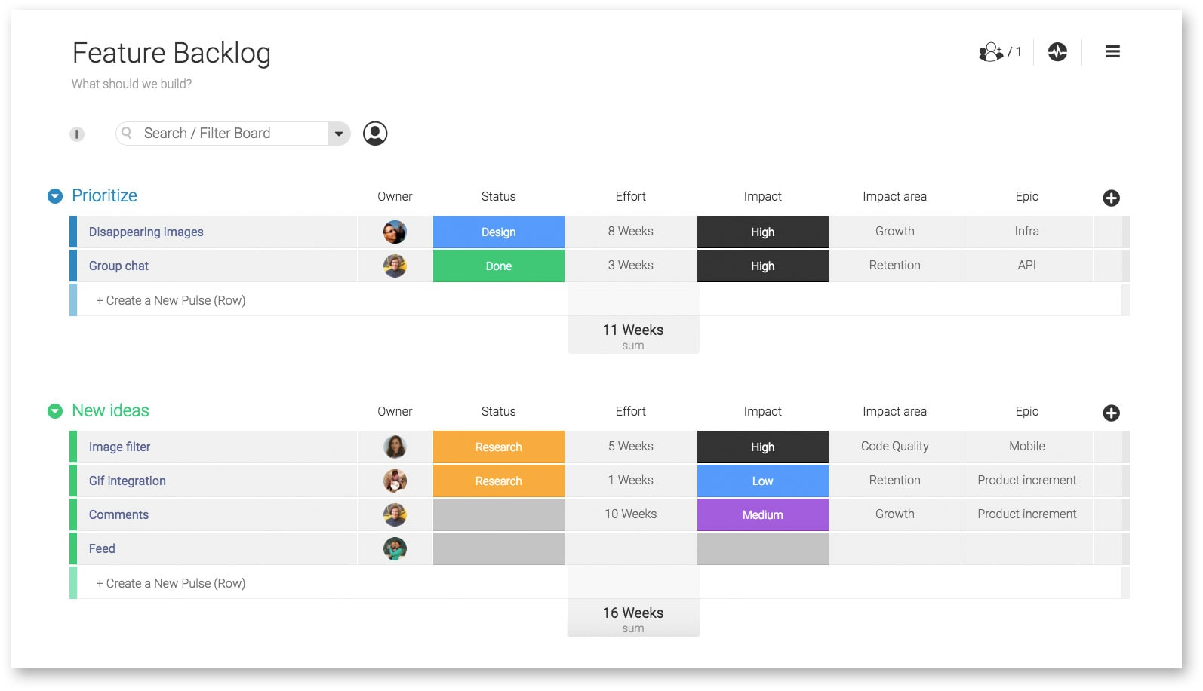

**Burndown Chart**

Burndown chart is a visual representation of how quickly the team is working through the user stories. For example:

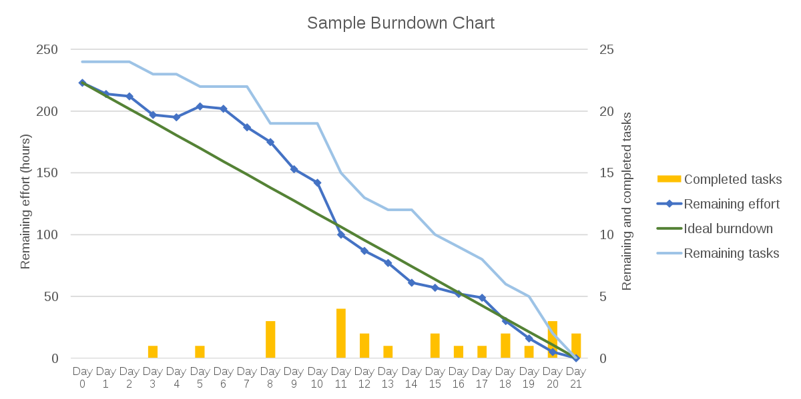

Your deliverable for this task is to answer multiple-choice questions in Step 5.